**Reg. No: 21BCE1297 Name: Vidhi Shah Date: 26/04/22**

**PPS13**

**Q1**

**Aim:**

Write a basic C++ program to generate Fibonacci series for ‘n’ numbers.

**Procedure:**

**Input:**

Number of elements of Fibonacci Series, n

**Output:**

Fibonacci series of n elements

**Algorithm:**

Step 1: Read n

Step 2: Initialise a, b, c. a=0, b=1

Step 3: Repeat steps 4 to 5 n times

Step 4: If i = 0 or i = 1 then print i

Step 5: Else

Step A: c = a + b

Step B: a = b

Step C: b = c

Step D: Print c

Step 6: Return 0

**Code:**

#include <iostream>

using namespace std;

int main() {

    int n, a = 0, b = 1, c, i;

    cout << "Enter N: ";

    cin >> n;

    cout << "Fibonacci Series: ";

    for (i = 0; i<n; i++) {

        if (i==0 || i==1)

        cout << i << " ";

        else {

            c = a + b;

            a = b;

            b = c;

            cout << c << " ";

        }

    }

    return 0;

}

**Output:**

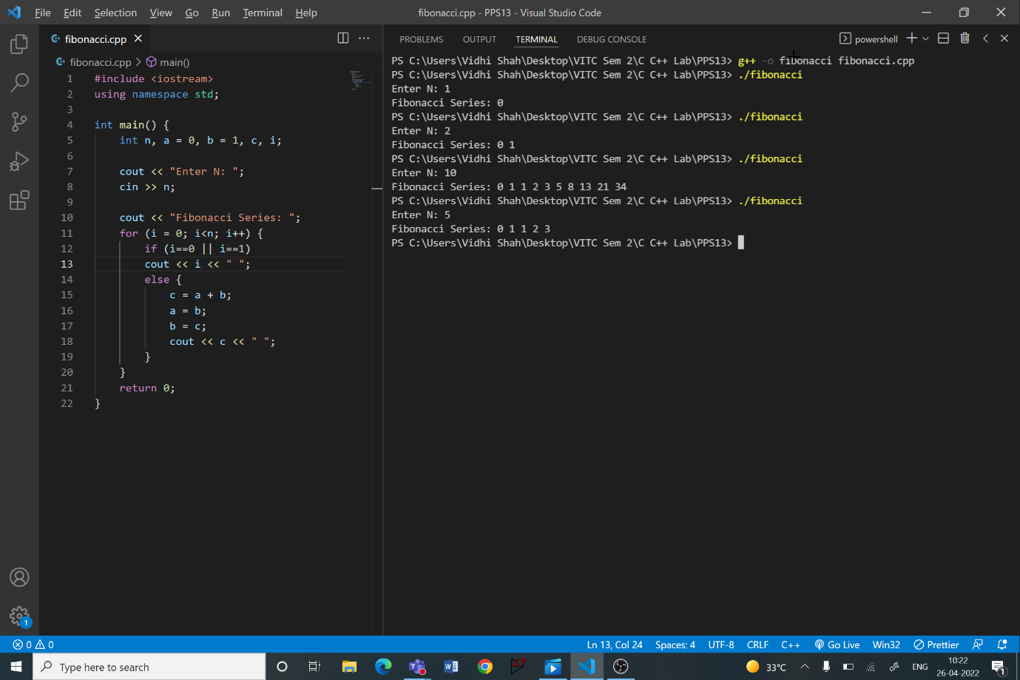

**Q2**

**Aim:**

Write a C++ program to generate the pay slip report for the employees working in an Organization. HRA is 12% and DA is 18% from basic salary for regular Employee, Print the Net Salary along with the name and id. Basic salary is a private data.

**Procedure:**

**Input:**

Employee Name

Employee ID

Basic Salary

**Output:**

Net Salary

**Algorithm:**

**Class Esalary:**

Step 1: Create a class Esalary

Step 2: Add private data members Employee ID, Name, Basic Salary, HRA, DA

and Net Salary

Step 3: Add public member functions

1. **Input function** that reads input for ID, Name and Basic Salary
2. **Net Salary function** that calculates HRA, DA and Net Salary
   1. HRA = 0.12*basic_salary
   2. DA = 0.18*basic_salary
   3. Net Salary = basic_salary + HRA + DA
3. **Output function** that displays ID, Name and Net Salary

**Main Function:**

Step 1: Create an object e1 from class Esalary

Step 2: Call the member functions

1. e1.input()
2. e1.netsalary()
3. e1.output()

Step 3: Return 0

**Output:**

